Auteur: Youssef Amarti

Versie: 0.1

Status: Concept

Datum: 1 september 2007

ITopia is onderdeel van de

Hogeschool van Amsterdam

Versiebeheer

|  |  |  |  |  |
| --- | --- | --- | --- | --- |
| **Ver.** | **Status** | **Datum** | **Auteur(s)** | **Wijzigingen** |
| 1.0 |  |  |  |  |
|  |  |  |  |  |
|  |  |  |  |  |

**Goedkeuring**

|  |  |  |  |  |  |  |
| --- | --- | --- | --- | --- | --- | --- |
| **No.** | **Recipient** | | **Position and Division** | | **No.** | |
| 1 | Arjen Jansen | Plaintech NL, Chief Executive Officer (CEO) | 1 | Arjen Jansen | Plaintech NL, Chief Executive Officer (CEO) | 1 |
| 2 | Irshad Rampersad | Plaintech NL, Chief Technical Officer (CTO) | 2 | Irshad Rampersad | Plaintech NL, Chief Technical Officer (CTO) | 2 |
| 3 | Wilko Oskam | Plaintech UK representative | 3 | Wilko Oskam | Plaintech UK representative | 3 |

Summary

In this document we have made all technical design aspects of project virtualization. This are the technical requirments that we are gonna fulfill for project virtualization. In the technical document we are gonna talk about the next subjects:

* Network design
* Network configuration
* System design
* System configuration

After this document you will get a idea of how the technical aspects of project virtualization is gonna be completed.

Table of contents

1. Network design 4

2. Network configuration 5

3. System design 6

4. System configuration 7

# Network design

In this chapter we let you see the basic network design voor project VIRT. It is a very simpel set up of the network design, As seen below we are using a http server for the hosting section. And debian virtual machine server for the hosting of the virtual servers for the client. The debian virtual machine server is only attainable if you are a authorized user of plaintech services. To make use of our services you have to be a registered user of plaintech. Or else you are a non authorized user and you can be band of our services.

# Network configuration

## Current network configuration

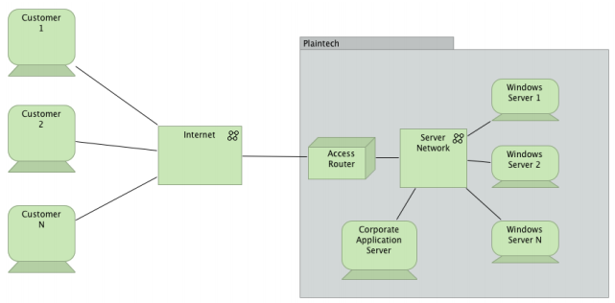

## Desired network configuration

## 

# System design

## System architecture

Our system design is based on the usage of the this the following hardware usage. Dell server with the following hardware configuration:

Server spec:

|  |  |
| --- | --- |
| Architecture | 64-bit |
| Number of CPU’s | 4 (2x Dual-Core Xeon-5150 @ 2.66GHz) |
| RAM | 8 GB RAM @ 667MHz (8x1GB) |

Allocated storage:

|  |  |
| --- | --- |
| Raid Type | Size |
| Raid 0 | 1 x 160GB @7200RPM |
|  |  |

Operating system partitions

|  |  |  |
| --- | --- | --- |
| Partition | Size | Type |
| 1 | 60 GB | OS |
| 2 | 100 GB | Back-up |

Network

|  |  |  |
| --- | --- | --- |
| DNS | VLAN | Ip |
| 145.92.14.250 | VIRT7 | 145.92.14.70 t/m 145.92.14.79 |

Required installed software

|  |  |  |
| --- | --- | --- |
| Software | Version |  |
| Debian | Latest |  |
| Ubuntu | 12.XX |  |
| Windows | server 2012 R2 |  |

Backup

|  |  |  |  |
| --- | --- | --- | --- |
| Partition | Frequency | Timeframe |  |
| 2 | Once every 24 hour | 06:00 |  |

## Coding requirments

### Website coding

For the development of the website for [www.plaintech.nl](http://www.plaintech.nl) we are gonna use the following development program Eclipse IDE. Also the following coding platform are allowed to use for developing in project VIRT.

* HTML/HTML5
* CSS
* Java
* Javascript
* Dojo

### Server coding

For the development of the server for project VIRT. We are gonna make use of the folllowing development program Eclipse IDE.Also the following codig platform are allowed to use for developing in project VIRT.

* HTML/HTML5
* CSS
* Java
* Javascript
* Dojo

### Server Software packet

For the making of the virtual server park, we are gonna make use of the following software pakket.

* Linux Debian
* Linux KVM
* Linux libvirt
* MySQL database server
* Apachte Tomcat
* Apache Velocity

# System configuration